Lab 08: Create a multi-tier solution by using Azure services

Microsoft Azure user interface

Given the dynamic nature of Microsoft cloud tools, you might experience Azure UI changes that occur after the development of this training content. As a result, the lab instructions and lab steps might not align correctly.

Microsoft updates this training course when the community alerts us to needed changes. However, cloud updates occur frequently, so you might encounter UI changes before this training content updates. **If this occurs, adapt to the changes, and then work through them in the labs as needed.**

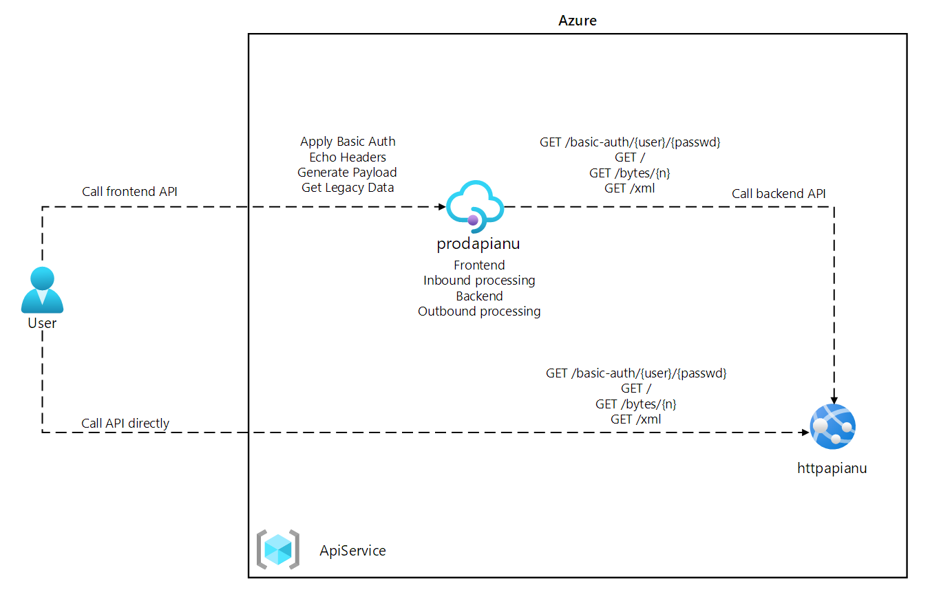

#### **Task 2: Create a web app by using Azure App Service resource by using an httpbin container image**

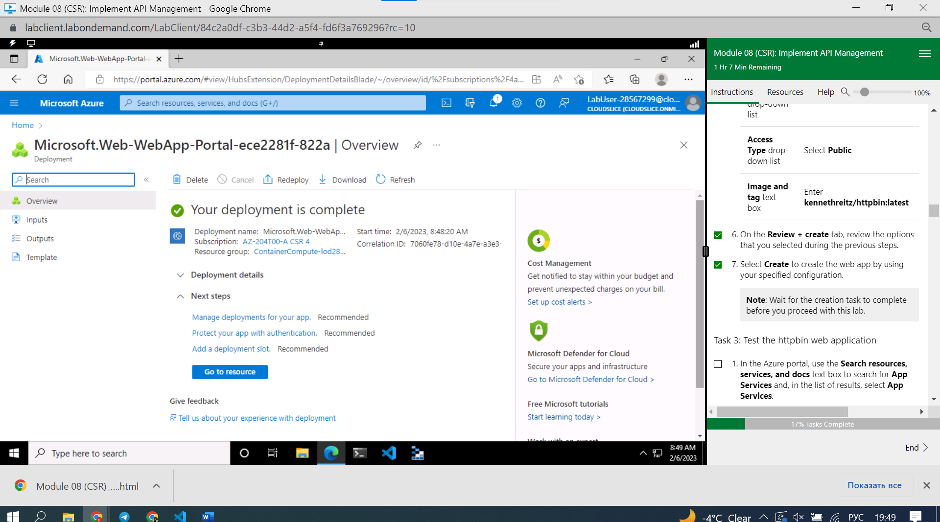

#### **Task 3: Test the httpbin web application**

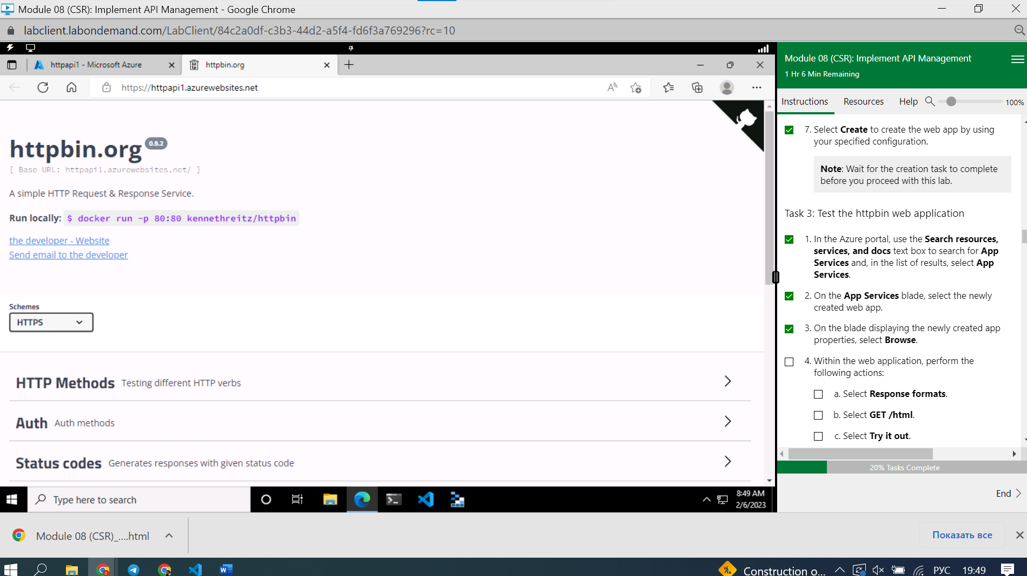

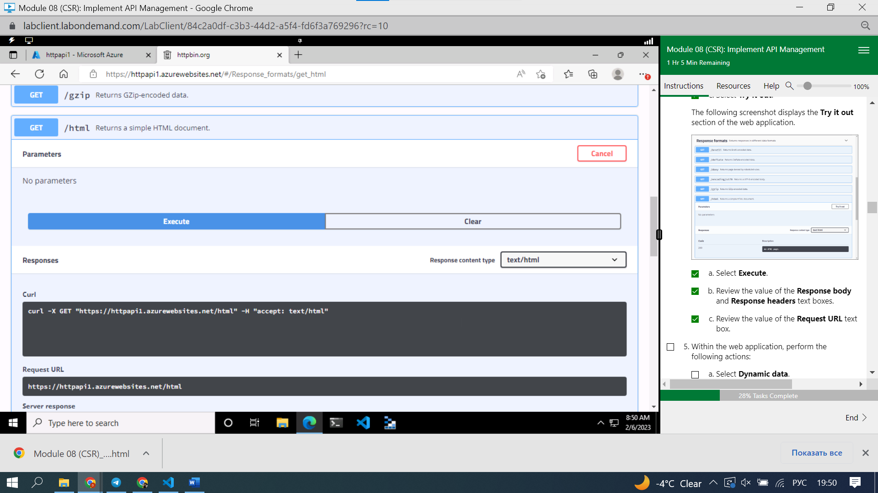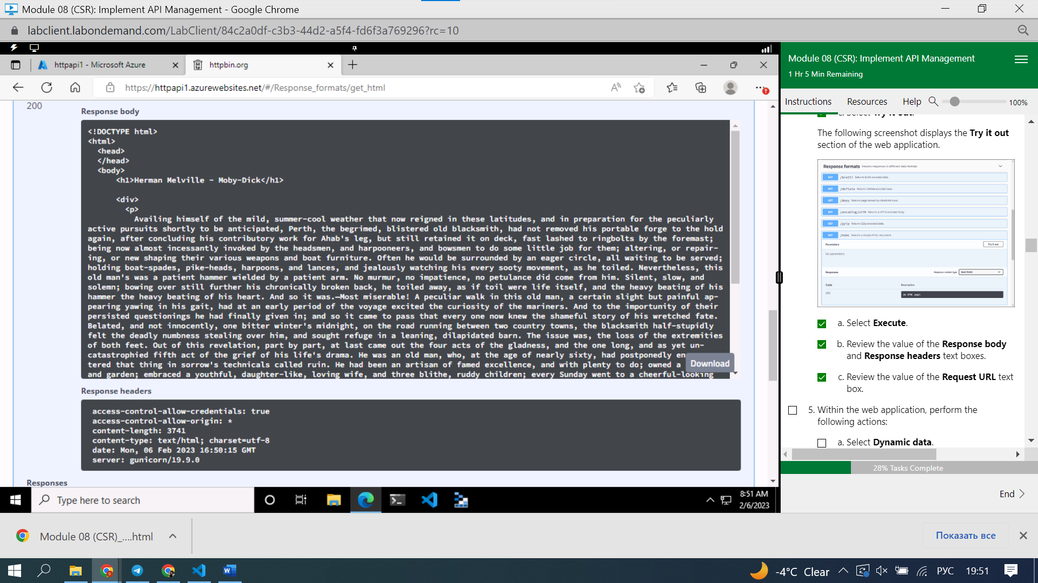

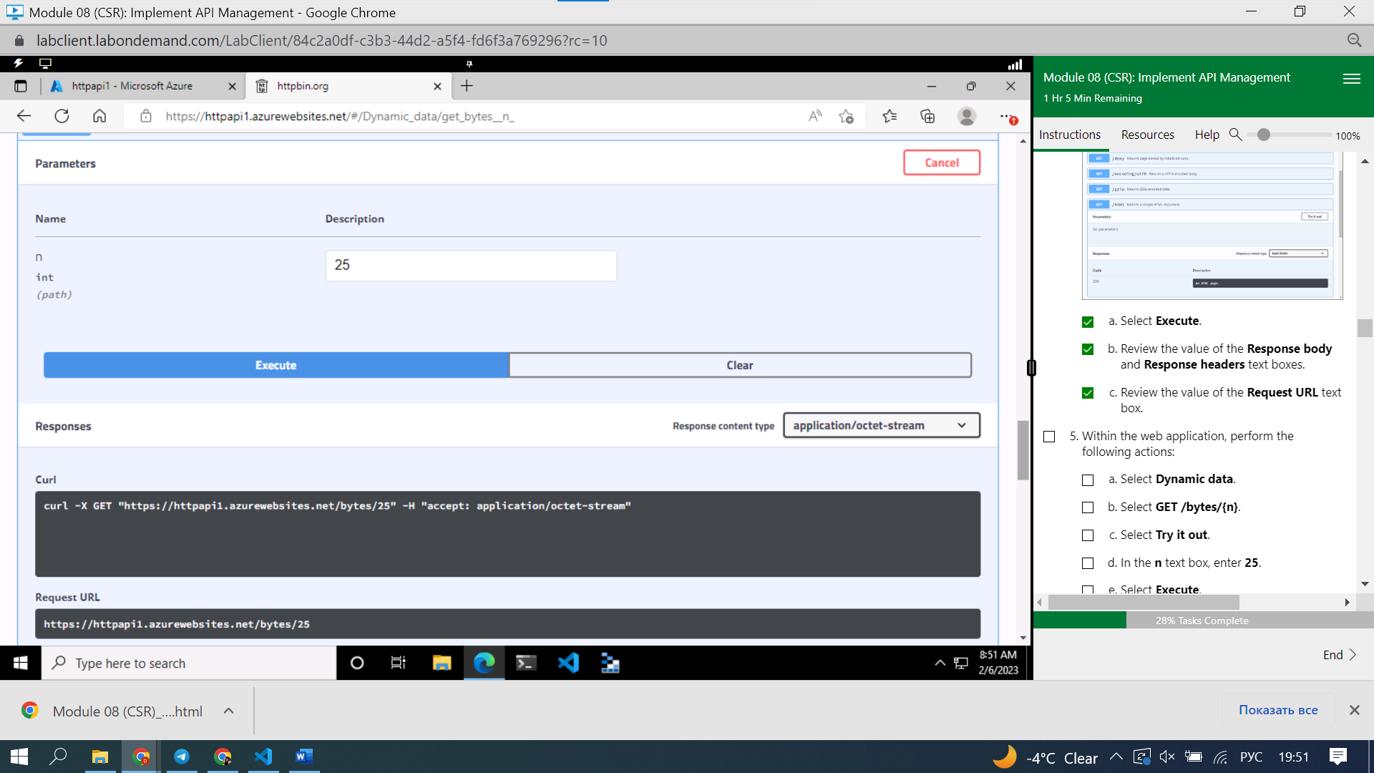

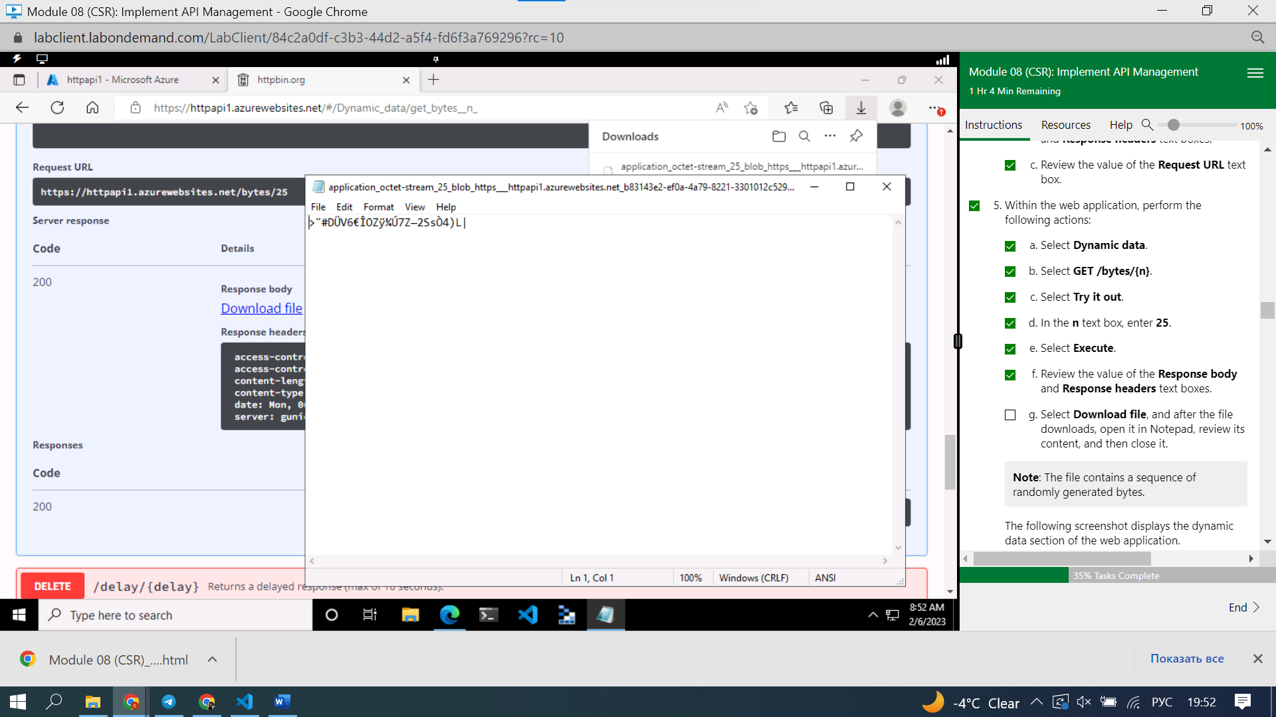

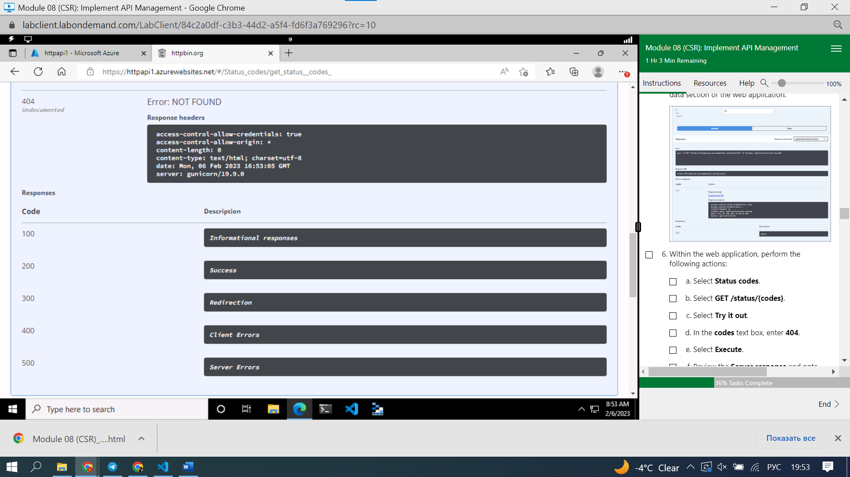

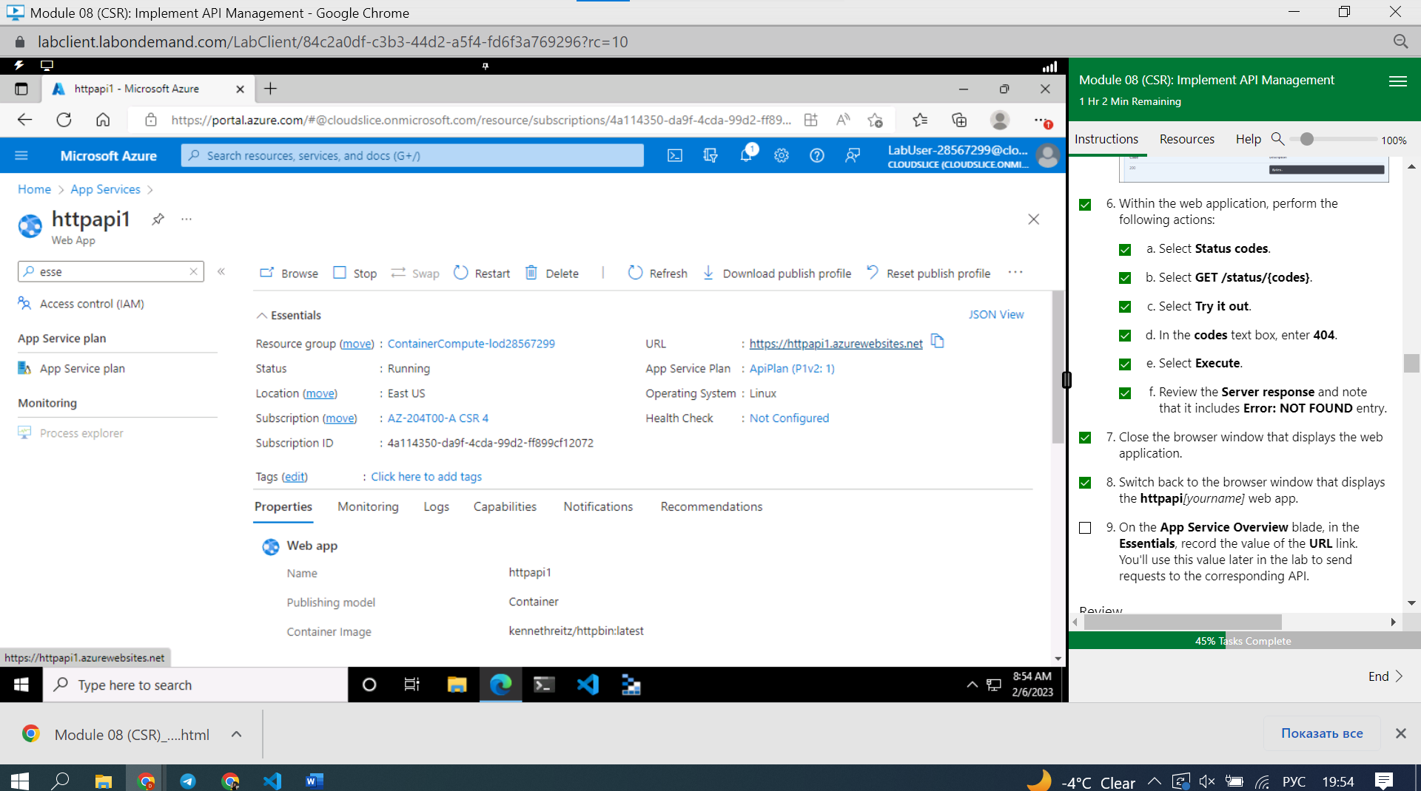https://httpapi1.azurewebsites.net

#### **Review**

In this exercise, you created a new Azure web app by using a container image sourced from Docker Hub.

### **Exercise 2: Build an API proxy tier by using Azure API Management**

#### **Task 1: Create an API Management resource**

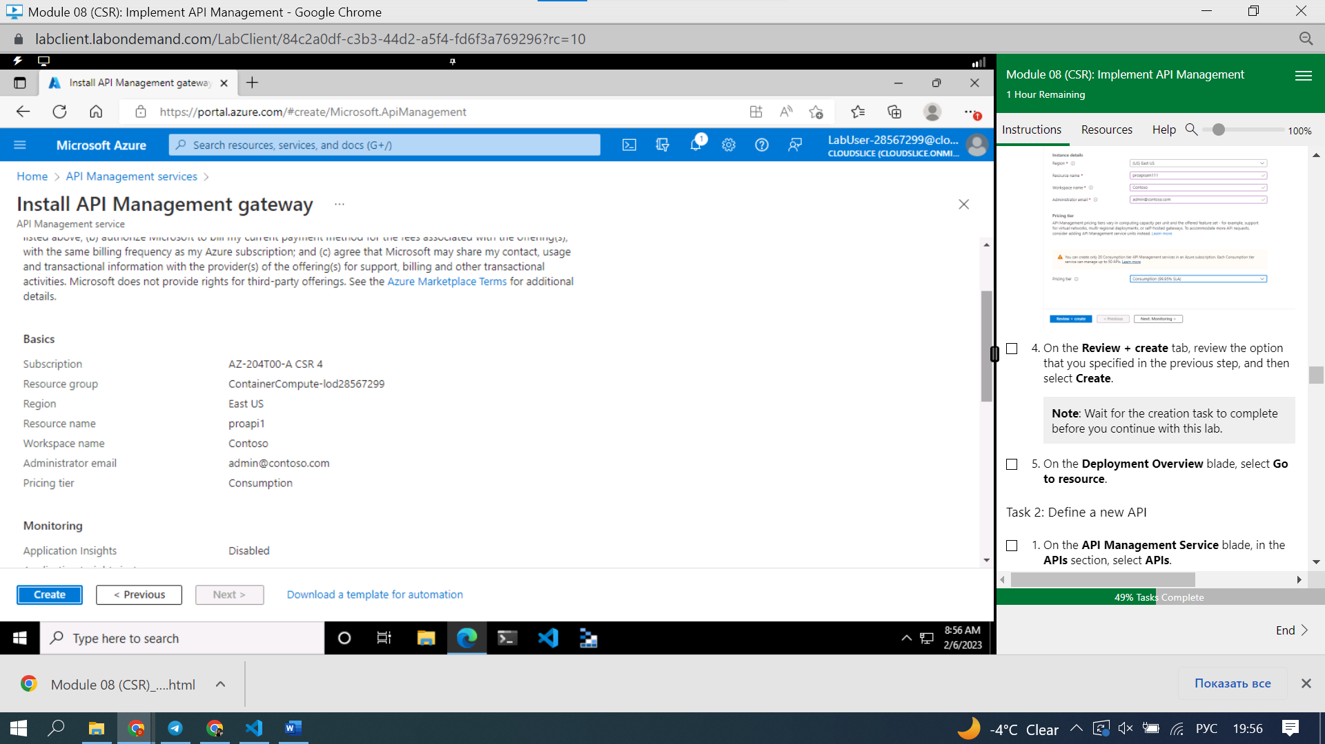

#### **Task 2: Define a new API**

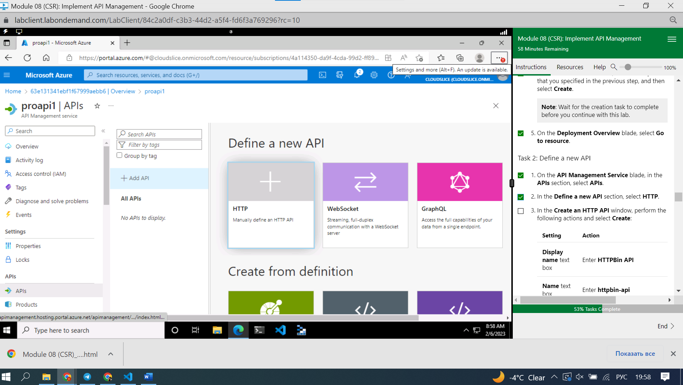

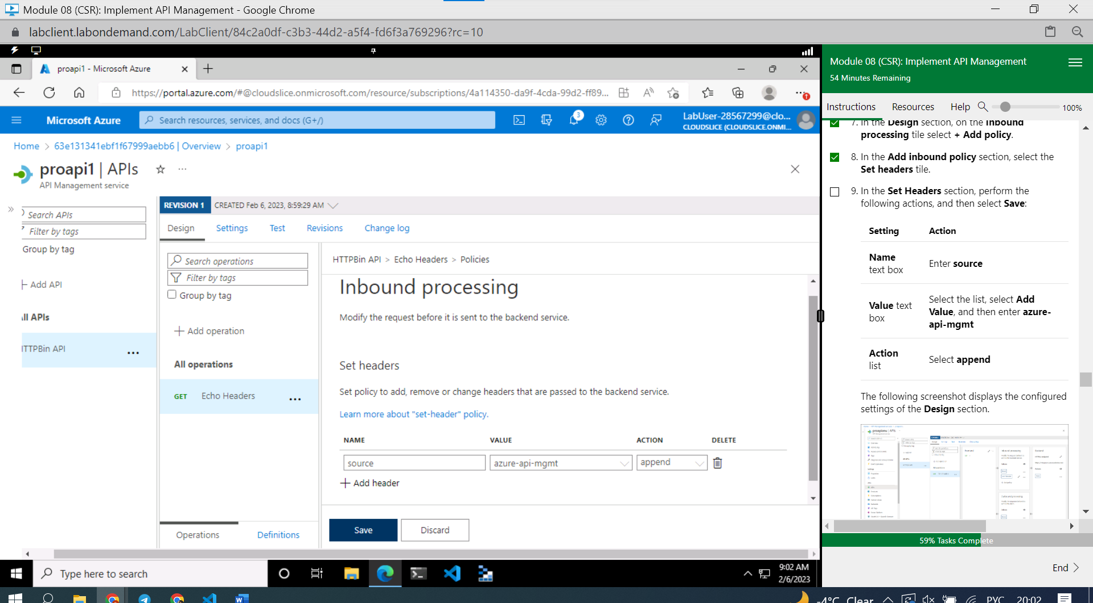

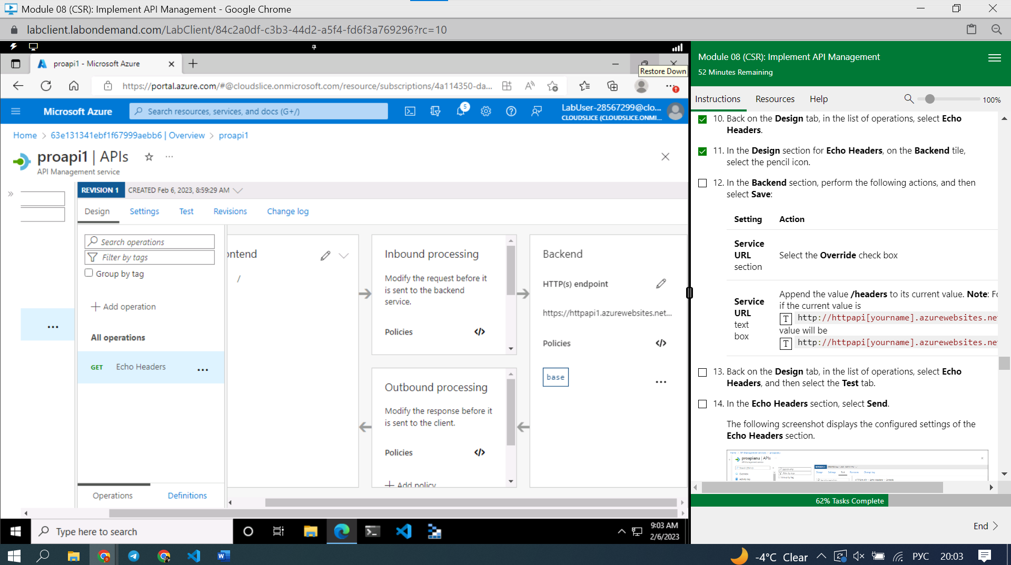

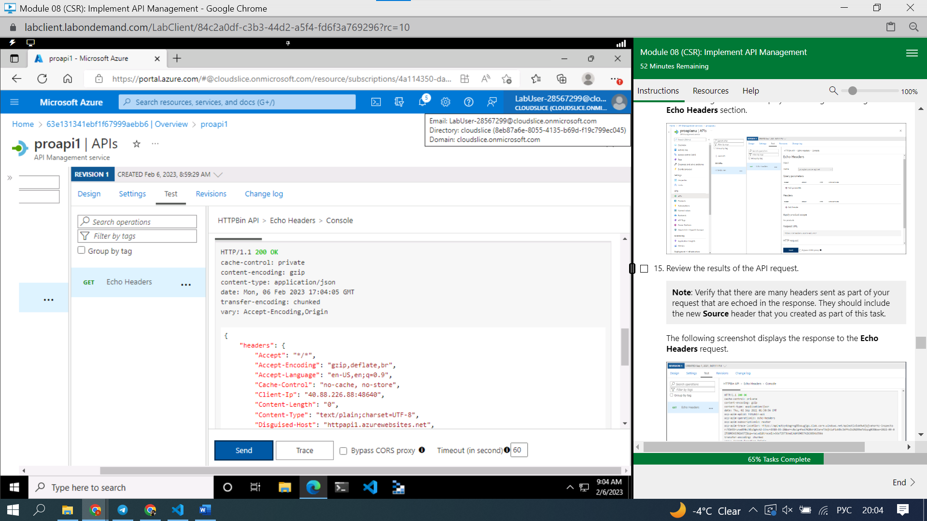

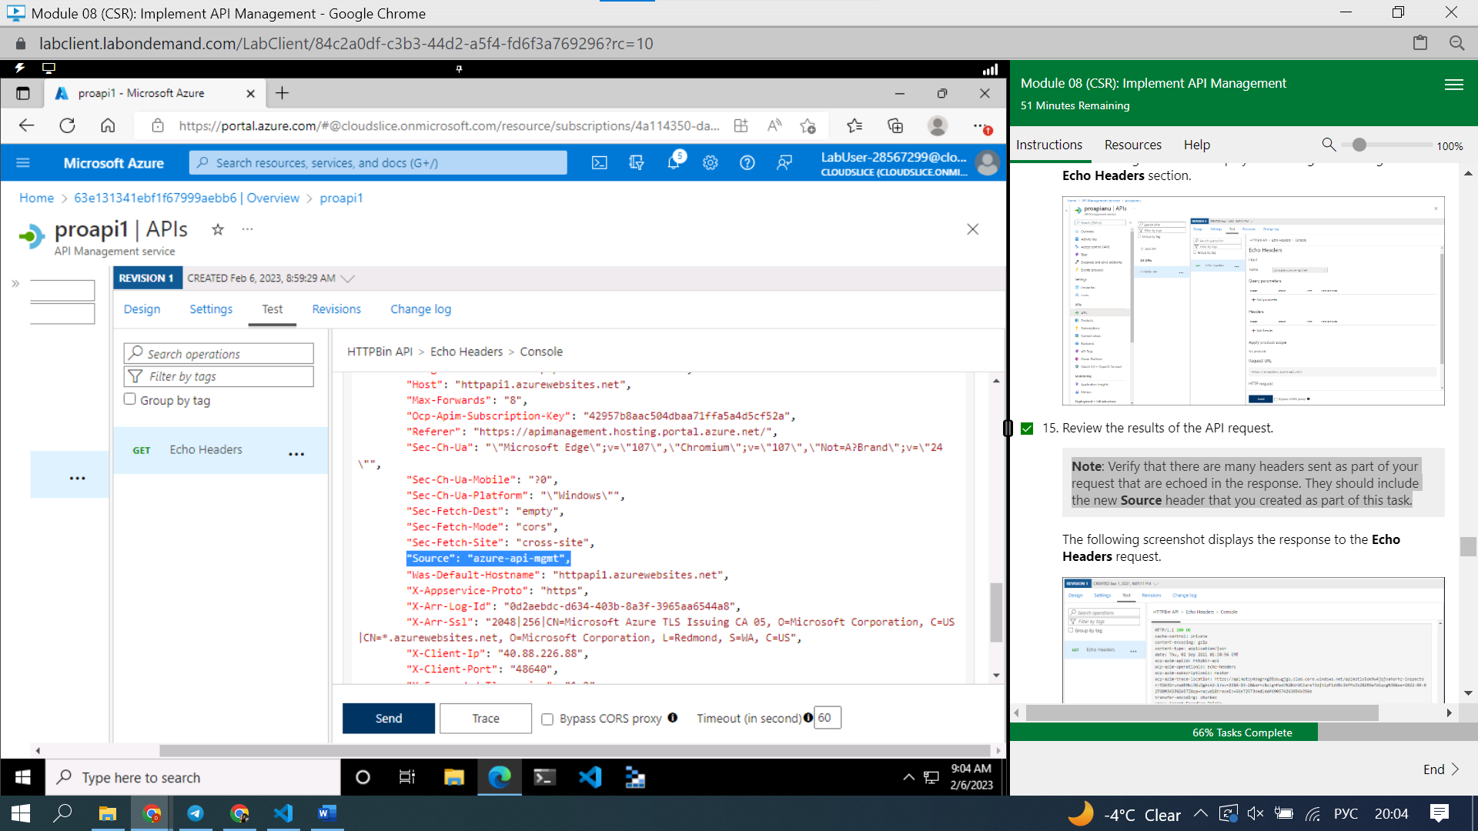

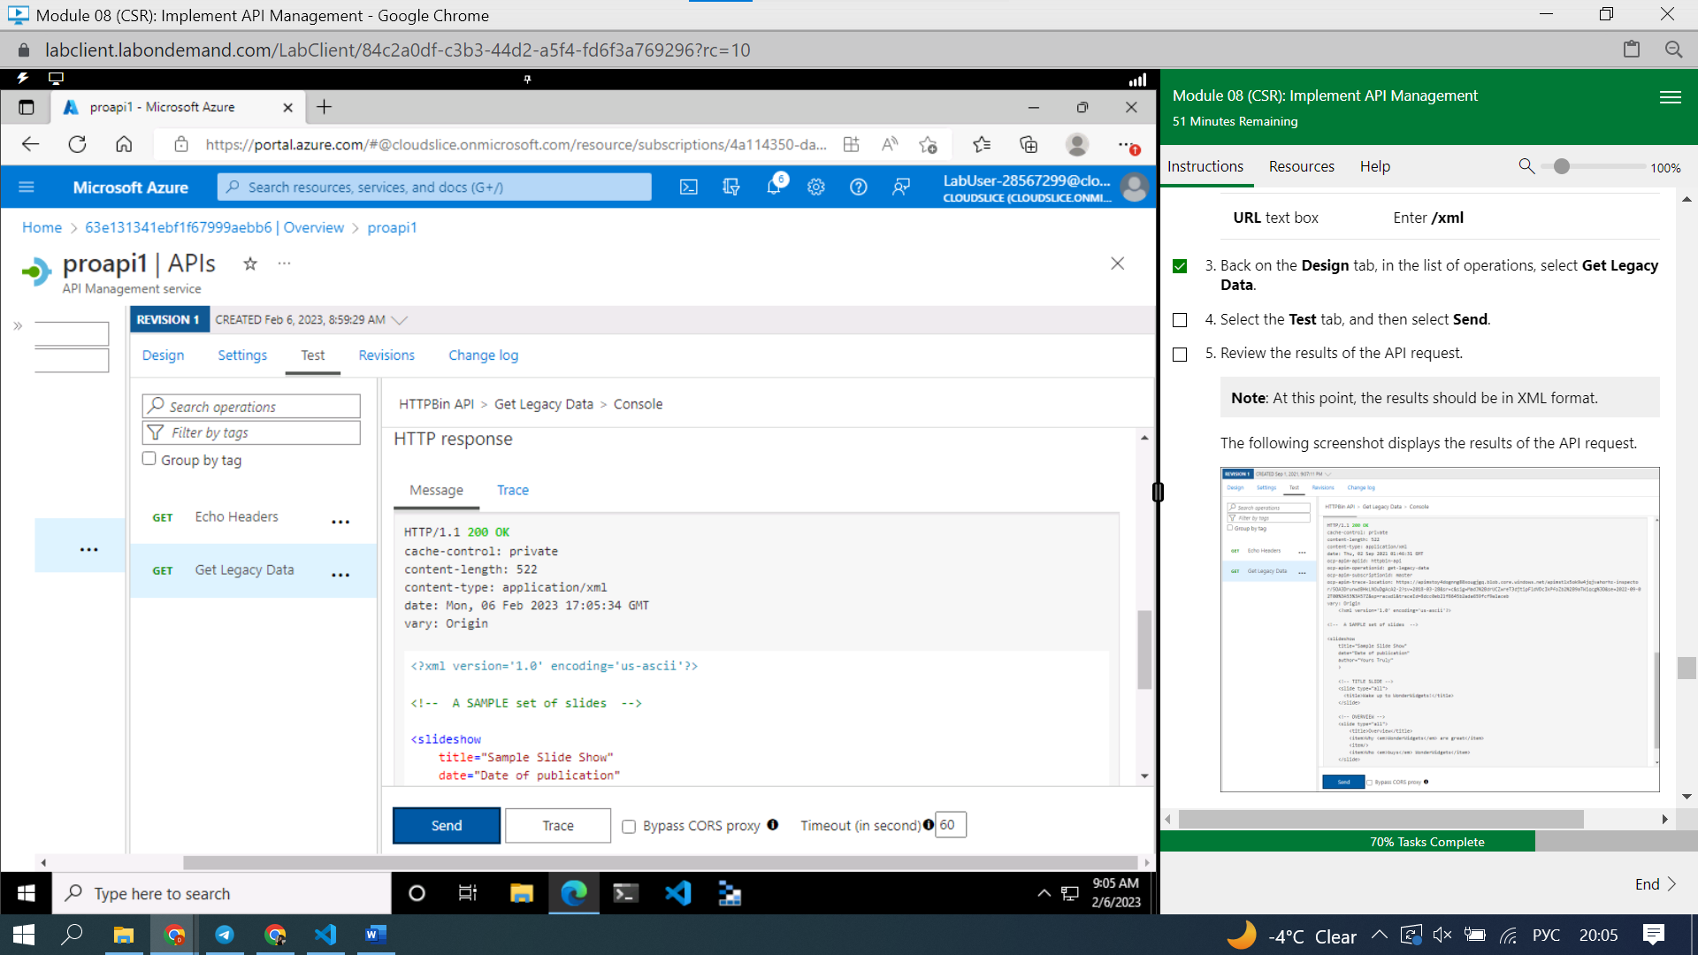 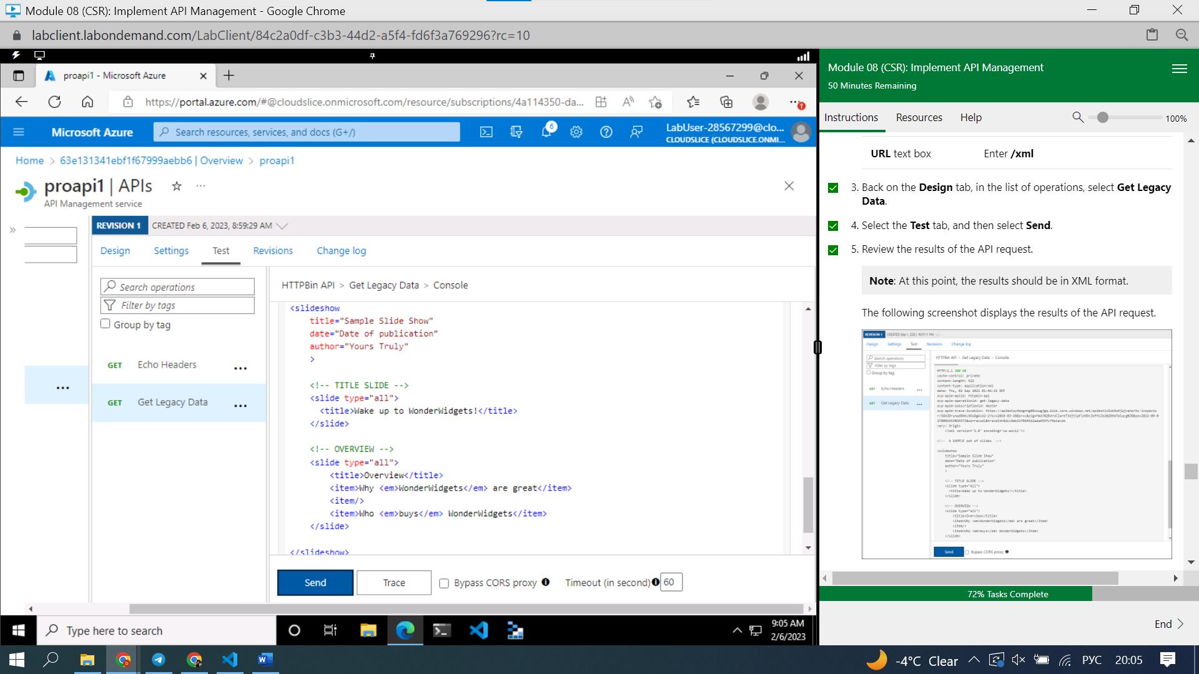

Add policy

Change … to

<outbound>

<base />

<xml-to-json kind="direct" apply="always" consider-accept-header="false" />

</outbound>

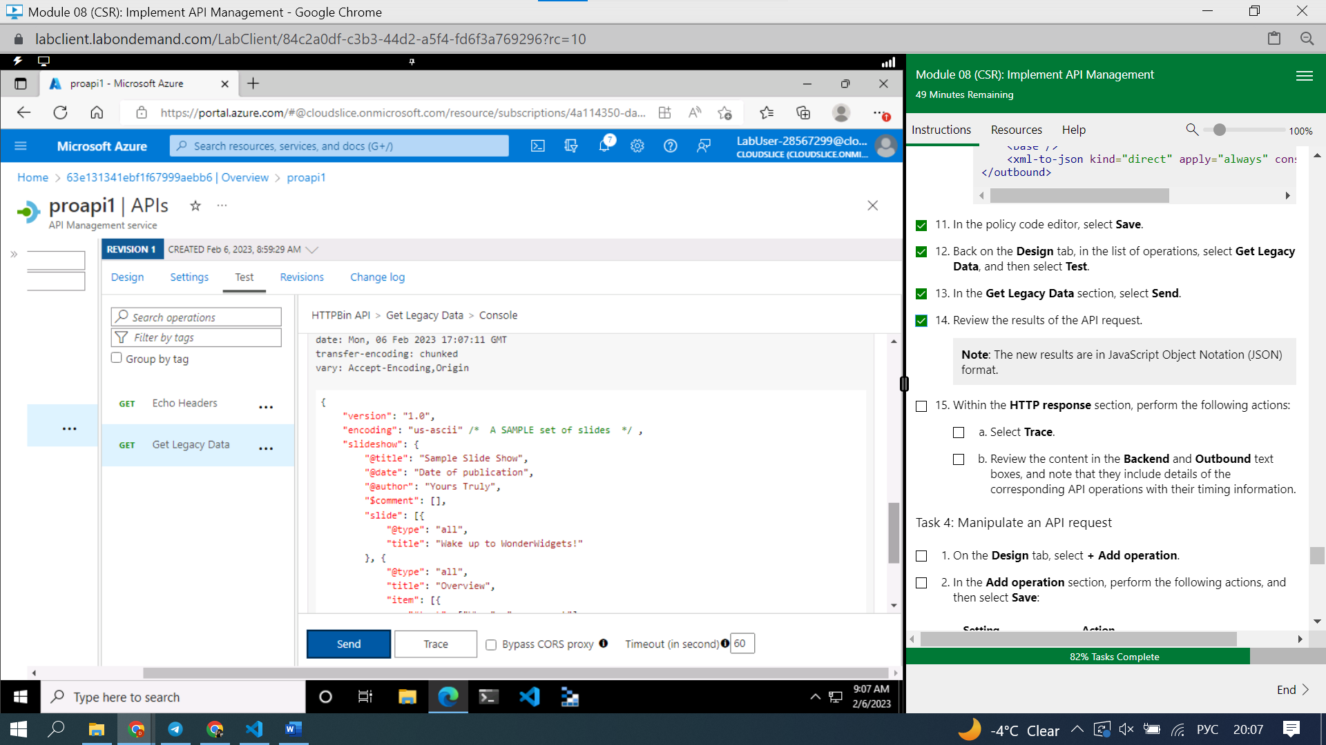

Backend

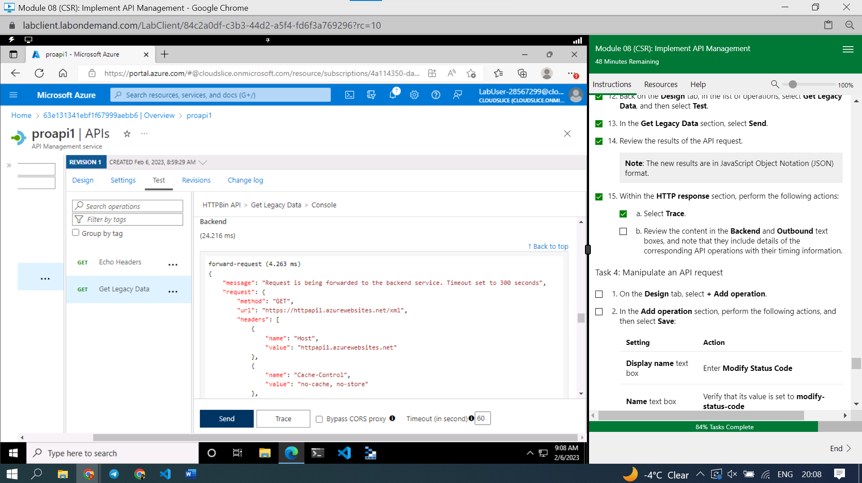

Outbound

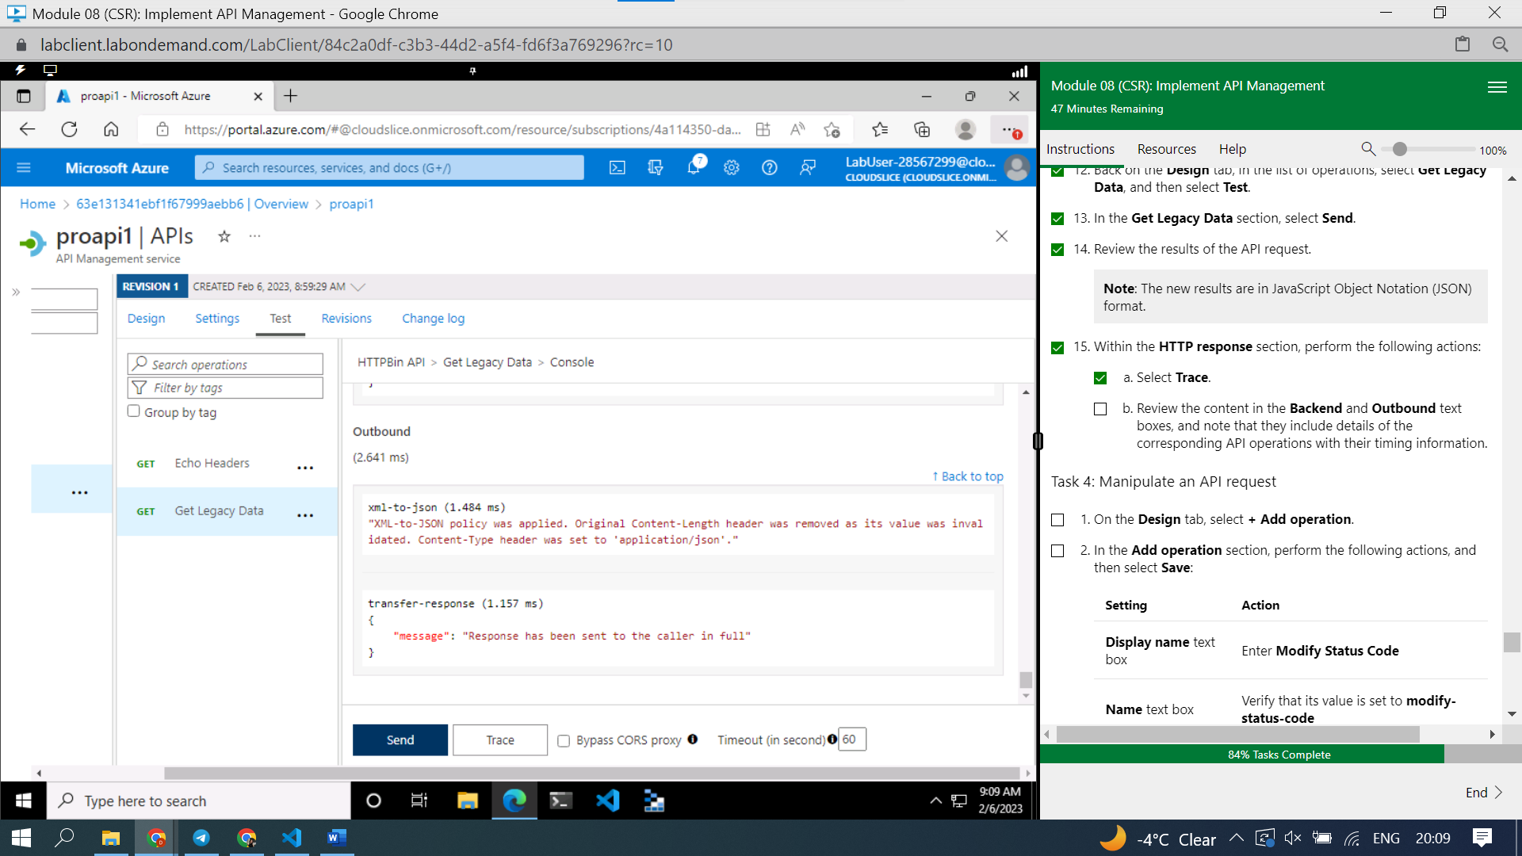

#### **Task 4: Manipulate an API request**

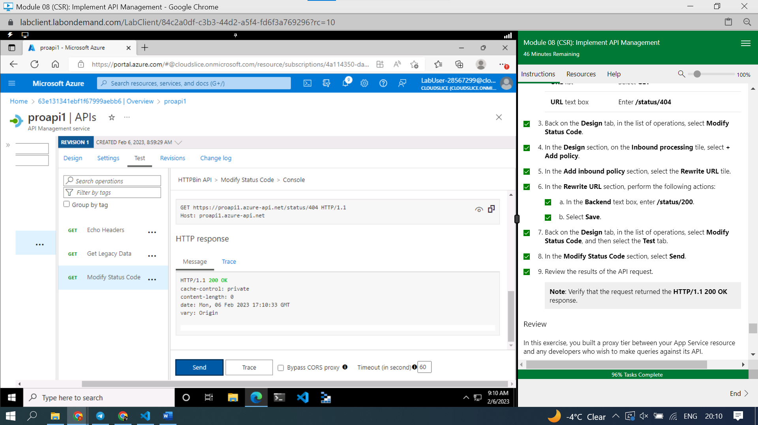

#### **Review**

In this exercise, you built a proxy tier between your App Service resource and any developers who wish to make queries against its API.